**Docker and Kali Linux:  
Kali Linux is Debian**

* more /etc/os-release

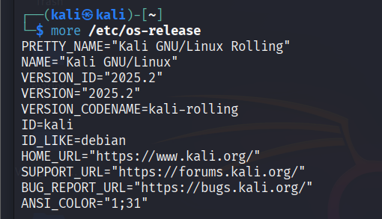

<https://docs.docker.com/engine/install/debian/>

**Uninstall old versions (if any using):**

for pkg in docker.io docker-doc docker-compose podman-docker containerd runc; do sudo apt-get remove $pkg; done

1. **Installation (using apt)**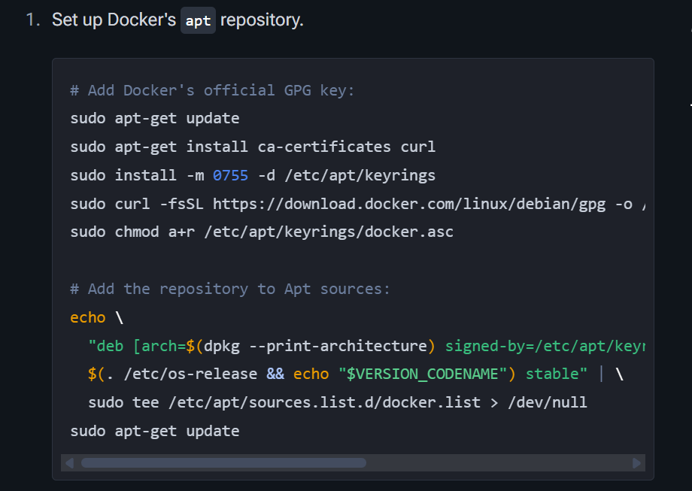

make sure to replace ‘*$(. /etc/os-release && echo "$VERSION_CODENAME")’* with *‘bookworm’*

and once update  
run below command for latest version

* sudo apt-get install docker-ce docker-ce-cli containerd.io docker-buildx-plugin docker-compose-plugin

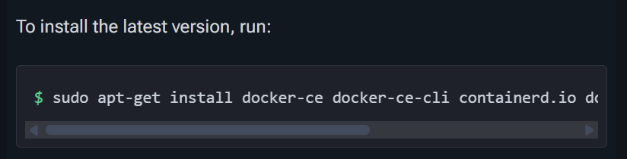

**Check Status of Docker**

* sudo systemctl status docker

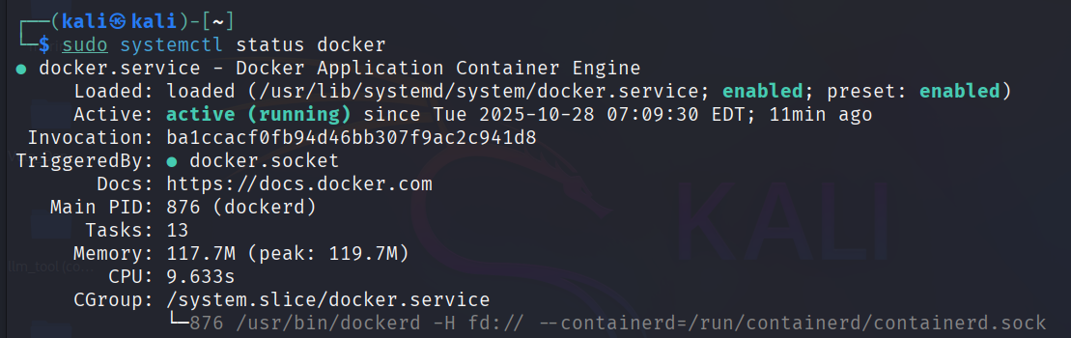

**Docker Version**

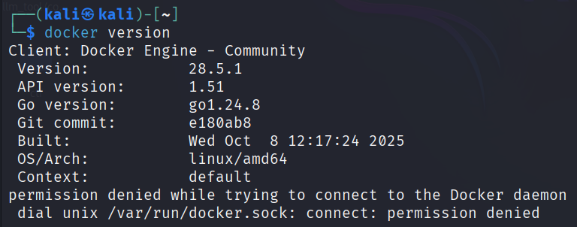

Here you can see kali user has denied permissions

**Permits Current User**

* sudo usermod -aG docker $USER
* and reboot

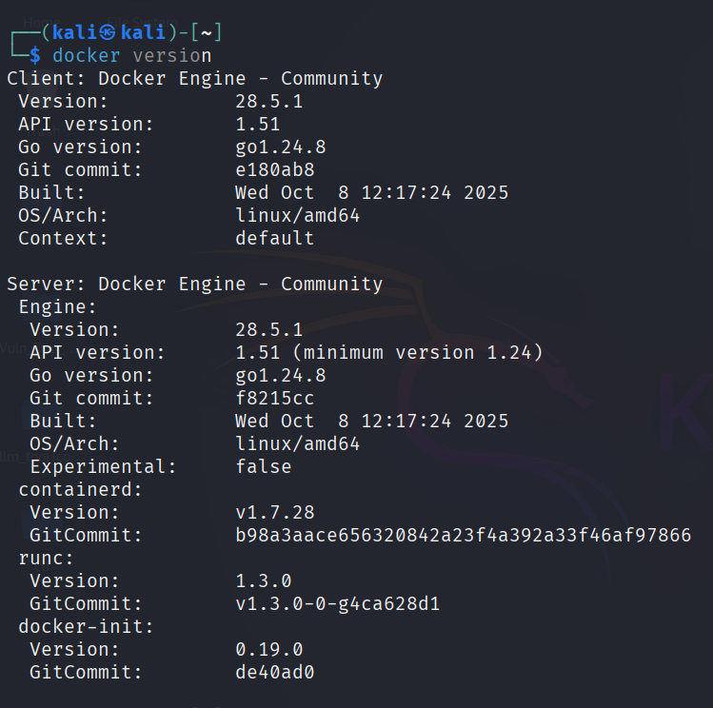

**Verify Installation**

* sudo docker run hello-world

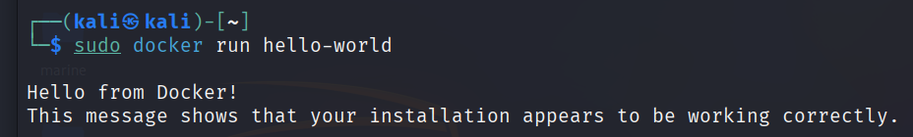

**To view application installed starting with docker**

* sudo apt list --installed docker*

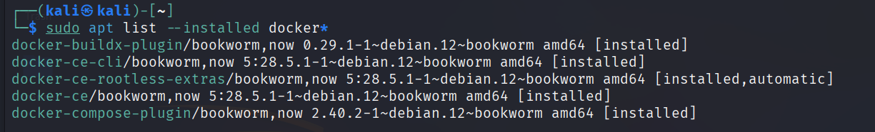

**For help**

* docker –help

**To see images available locally**

* docker images

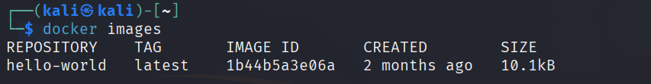

For now, I have only single image ‘hello-world’ in my system

**To list running containers**

* docker ps

**To list running + stopped containers**

* docker ps -a

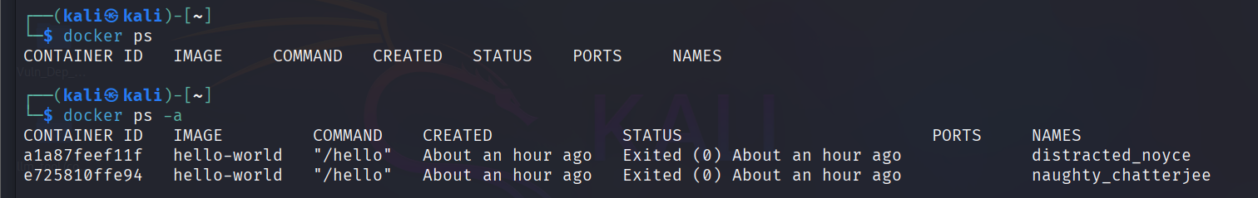

Here we can see for **same image we have two container** ‘hello-world’ it has two entries because we have run the image twice therefore two containers are created

Each time we run an image it will generate a container that consists of all dependency required to run an image.

**To remove a container entry**

* docker rm e725810ffe94
* docker rm container_id



1. **Work with image**

Go to <https://hub.docker.com/>

And search for nginx <https://hub.docker.com/r/ubuntu/nginx>

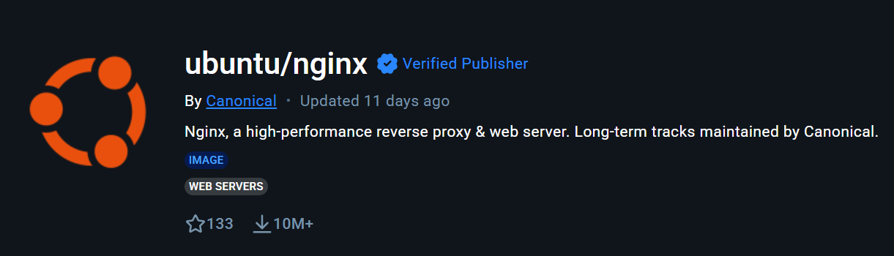

**To download an image, we use pull command**

* docker pull ubuntu/nginx:1.18-20.04_beta

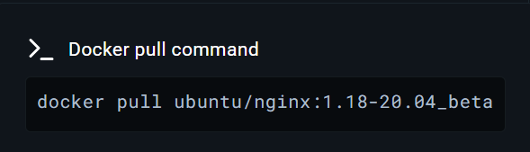

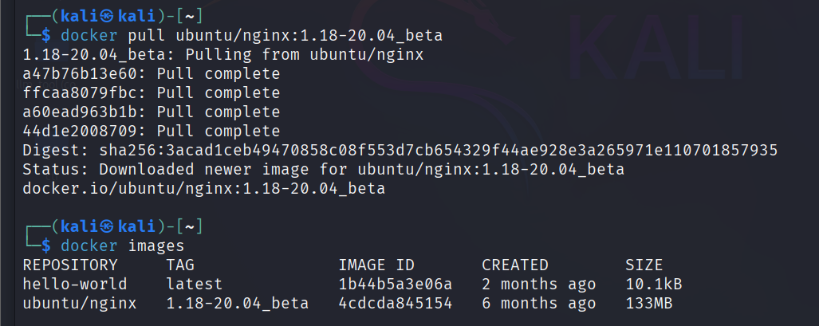

Now we have two images

* docker run -d --name nginx-cont-bychhavi -e TZ=UTC -p 8080:80 ubuntu/nginx:1.18-20.04_beta

-d : detached mode i.e in background

--name : allow us to give friendly name to container

-e : for timezone lets keep it default as docker hub

-p : bind port of host OS to port that is being exposed in container. To run service like web server.

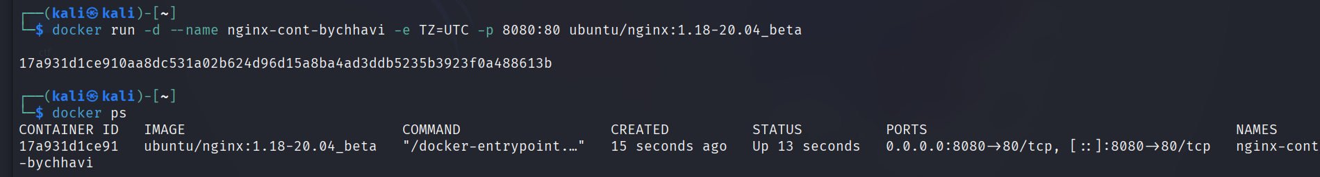

Localhost:8080

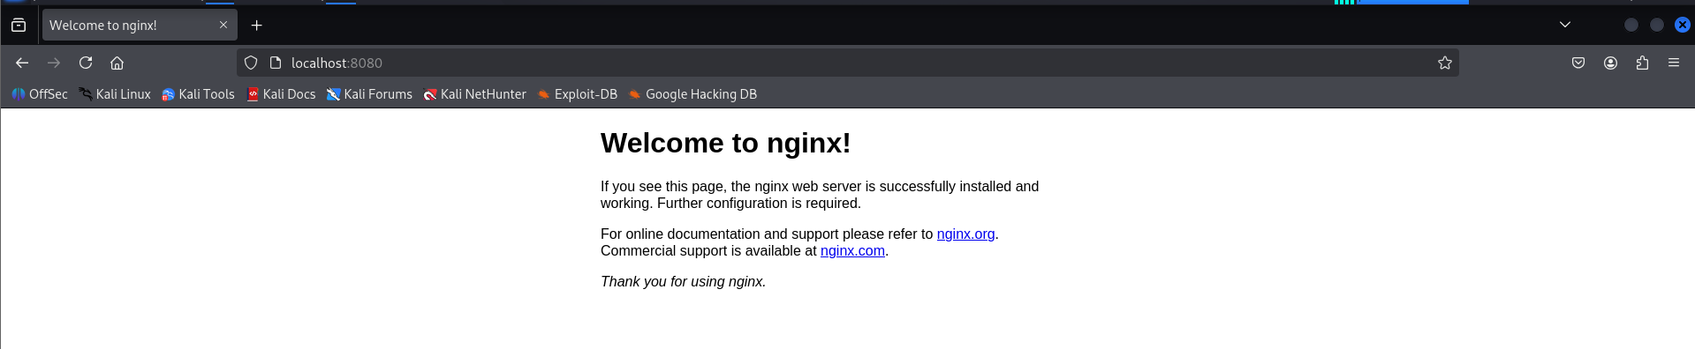

**To stop the container**

* docker stop container_id

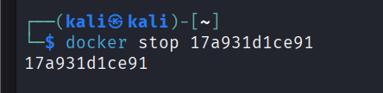



**To re-run a container**

We will use ‘start’ command not ‘run’ because

* ‘*docker run’* generates copies of container therefore duplicity as we have seen it in *‘docker ps -a’*
* docker start container_id



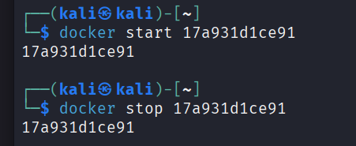

**To check logs**

* docker logs container_id

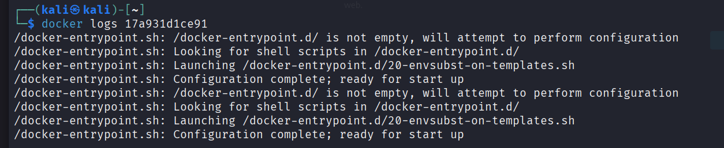

You generate logs each time you run a container (here two-time same logs are repeated)

To read and know about more commands you can visit docker docs  
<https://docs.docker.com/reference/cli/docker/>

**Create your image and deploy on docker hub then pulling it again**

1. **Creating a project**

* Create a folder
* Navigate into it
* Create a java file
* Compile code
* Add manifest
* Create a jar file
* mkdir temp
* cd temp
* nano HelloWorld.java *(pure source code)*

public class HelloWorld{

public static void main(String... args){

System.out.println(

"****************\n"+

"****************\n"+

"****************\n"+

"Hello World !\n"+

"****************\n"+

"****************\n"+

"****************\n");

}

}

* javac -verbose HelloWorld.java

*compiling using ‘javac’ java compiler installed using ‘sudo apt install default-jdk -y’*

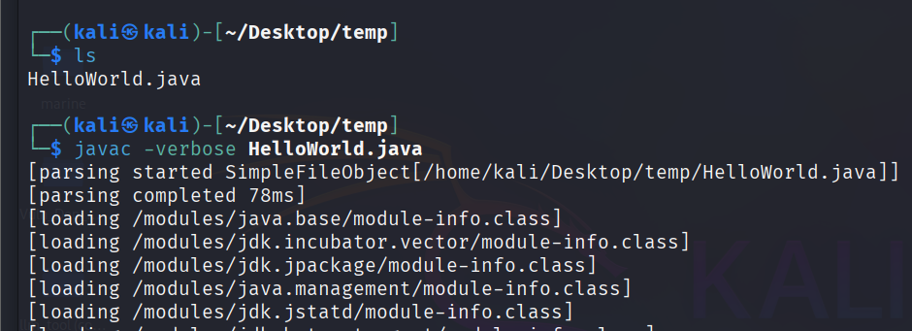

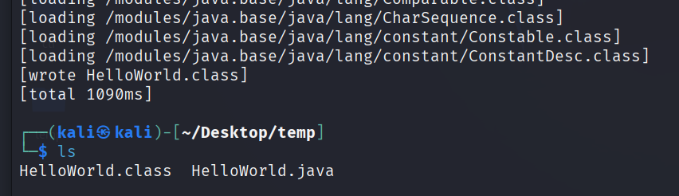

Now we have two files .class and .java

* nano manifest.txt

Manifest-Version: 1.0

Created-By: bychhavi (chhaviorg.com)

Main-Class: HelloWorld

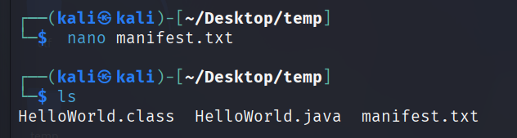

* jar -cfmv HelloWorld.jar manifest.txt HelloWorld.class

c: create  
f: file  
m: manifest   
v: verbose

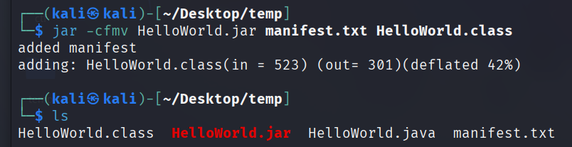

* java -jar HelloWorld.jar

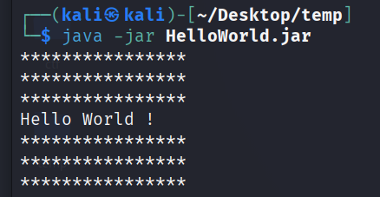

Now we have in total these many files

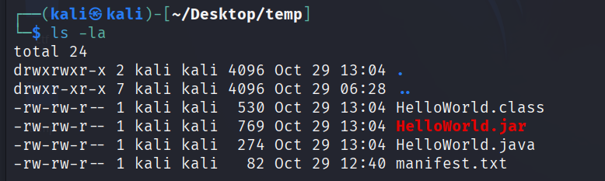

1. **Create Dockerfile (acts as blueprint for docker image)**

Docker builds images by reading the instructions from a Dockerfile. A Dockerfile is a text file containing instructions for building your source code.

<https://docs.docker.com/build/concepts/dockerfile/>

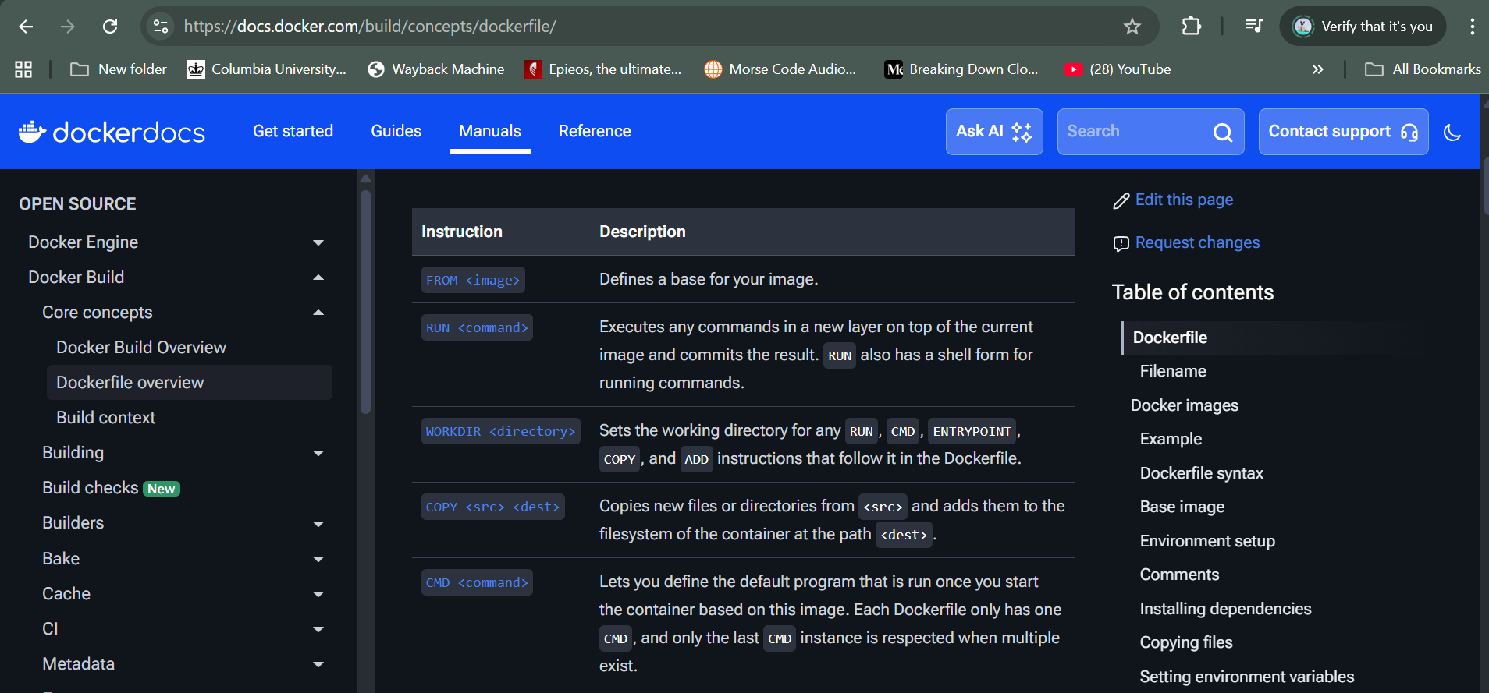

* nano Dockerfile

FROM openjdk:18 *(base image from dockerhub so user don’t have to setup openjdk)*

WORKDIR / *(working directory of container to run instructions/command)*

COPY HelloWorld.jar HelloWorld.jar *(copying file from local system to container)*

CMD java -jar HelloWorld.jar *(command to run when container starts)*

**

* docker build -t helloworld .

-t: tag

helloword: name of image

.: represent the directory where Dockerfile is present, here we are already present in the directory therefore we used . only

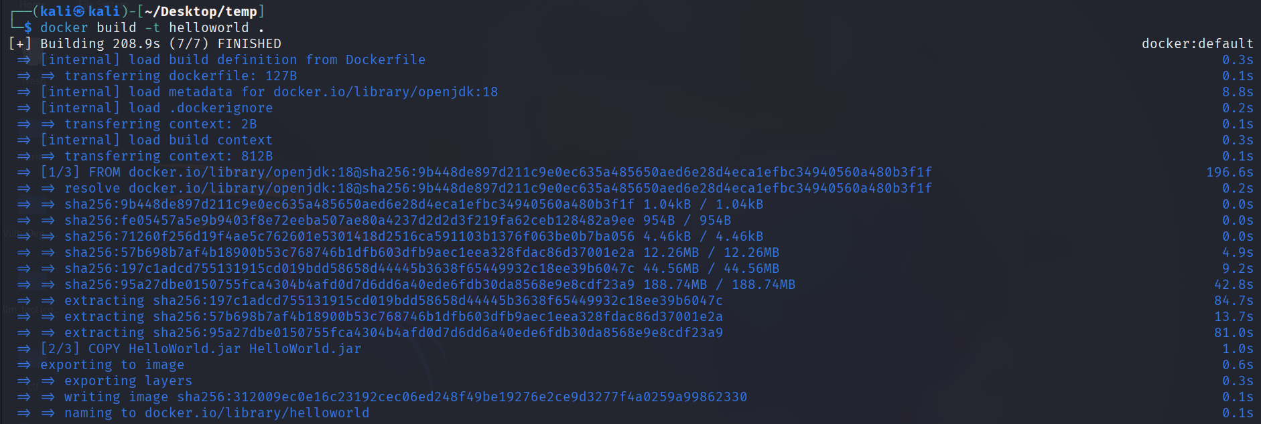

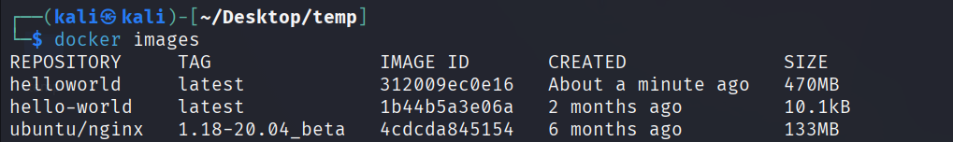

We have our new image helloworld created!

* docker run -it helloworld



Here I was facing this error then I realized my code is compiled with Java 21 and the Java Runtime inside my Docker image only supports up to Java 18.  
therefore I changed 18 to 21 FROM openjdk:21  
then rebuild the image and when I ran it again it worked

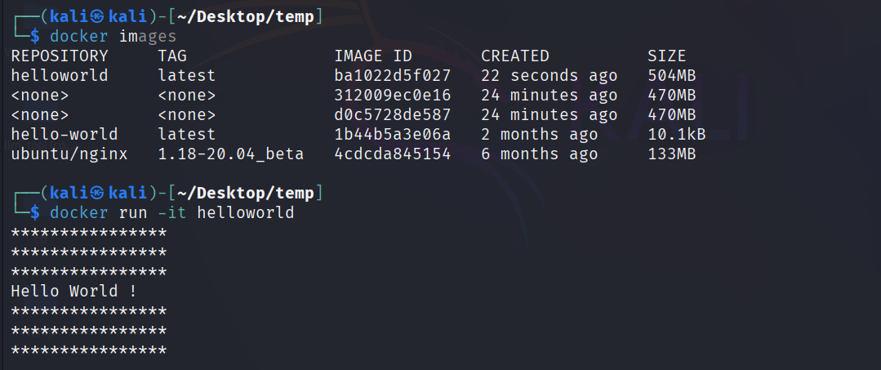

In the above image you can see repository *<none> .* They're called **dangling images** leftover layers from previous builds that are not tagged.

These images occupy disk space therefore we need to remove them.

* Docker image prune  
  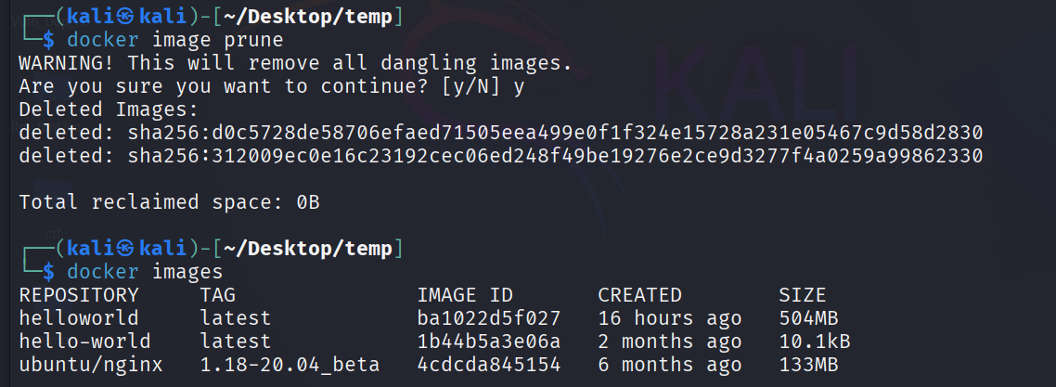

Now we have an image that contains all the dependency (openjdk runtime) that are required to run the image.  
Next step is to upload it or push it to Docker hub so that any user can use it by directly pulling it from Docker hub without the need to install any dependency.

1. **Pushing to Docker hub**

* Sign up to Docker Hub
* Create a repository and add a description

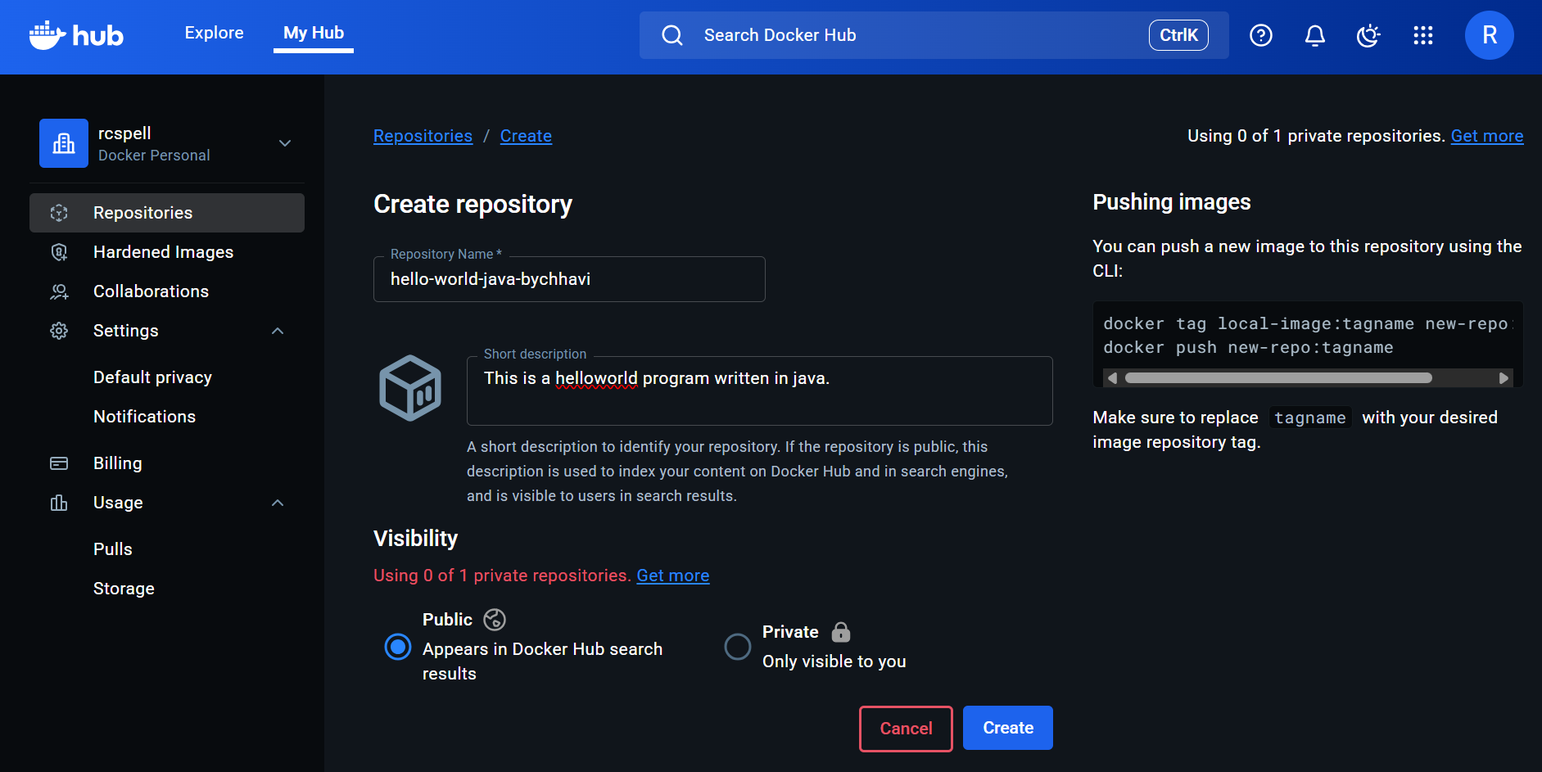

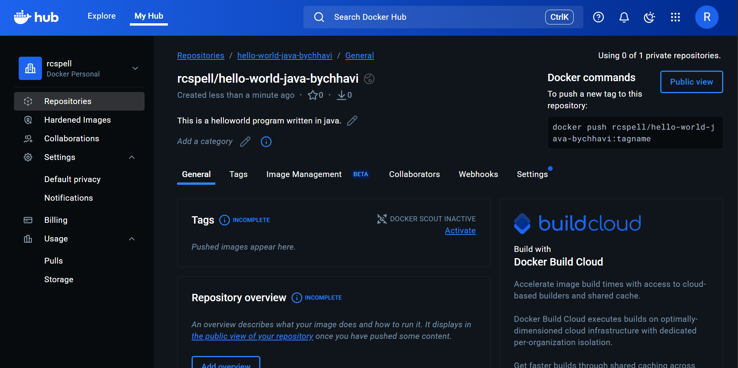

Now we are going to use the above highlighted command to push this image into our system

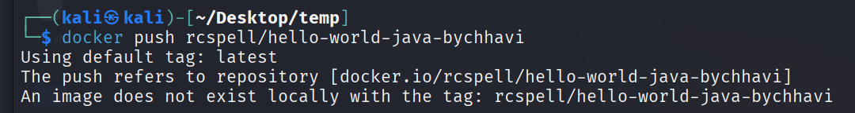

But here you can see it say *“image does not exist locally with the tag: rcspell/hello-world-java-bychhavi”*

Therefore, we are going to change the tag of our local *“helloworld”* to *“rcspell/hello-world-java-bychhavi”*

And then we will push it again

* docker tag helloworld rcspell/hello-world-java-bychhavi
* docker push rcspell/hello-world-java-bychhavi

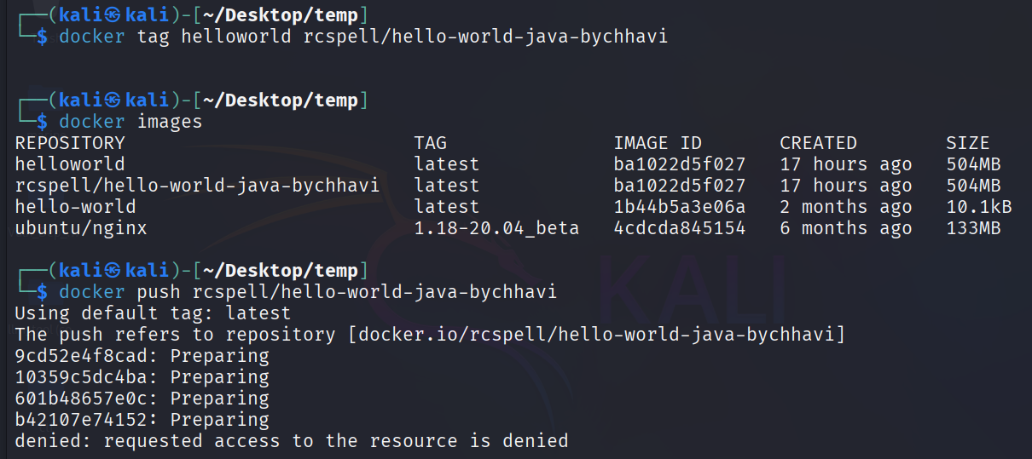

Here we see access is denied  
Let’s login first

* docker login -u *<username>*

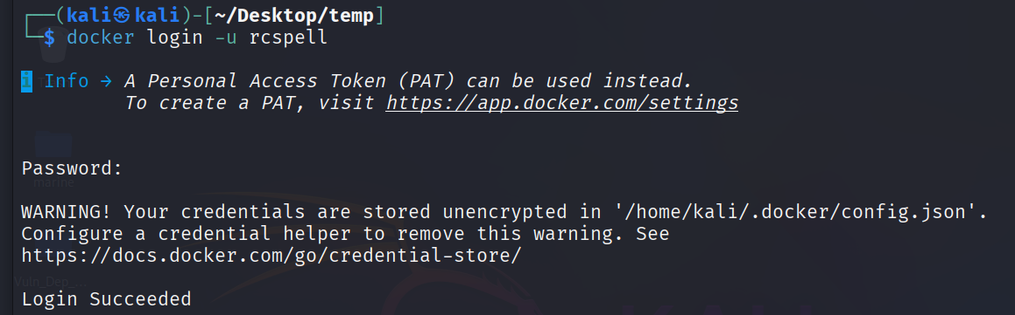

You can either use password or generate a Personal Access Token (PAT)

Here I used PAT

**Generation of PAT Token**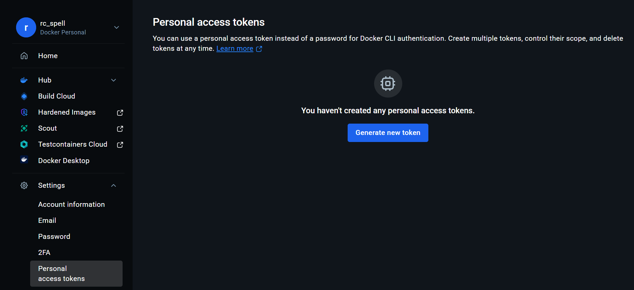

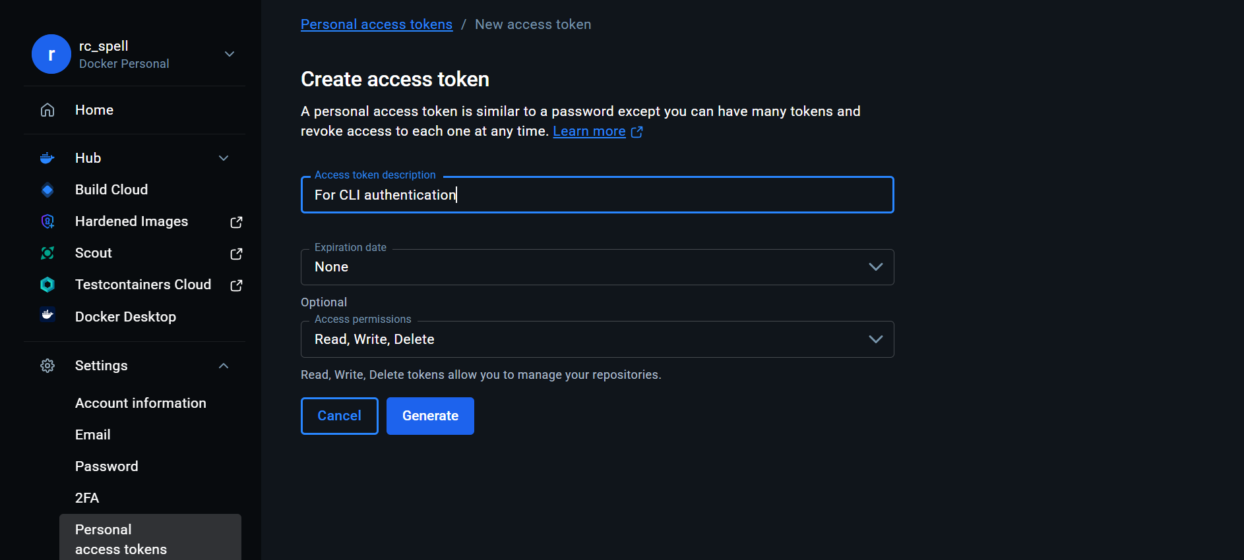

Generate and use in CLI login *(you can deactivate, delete and edit it anytime)*

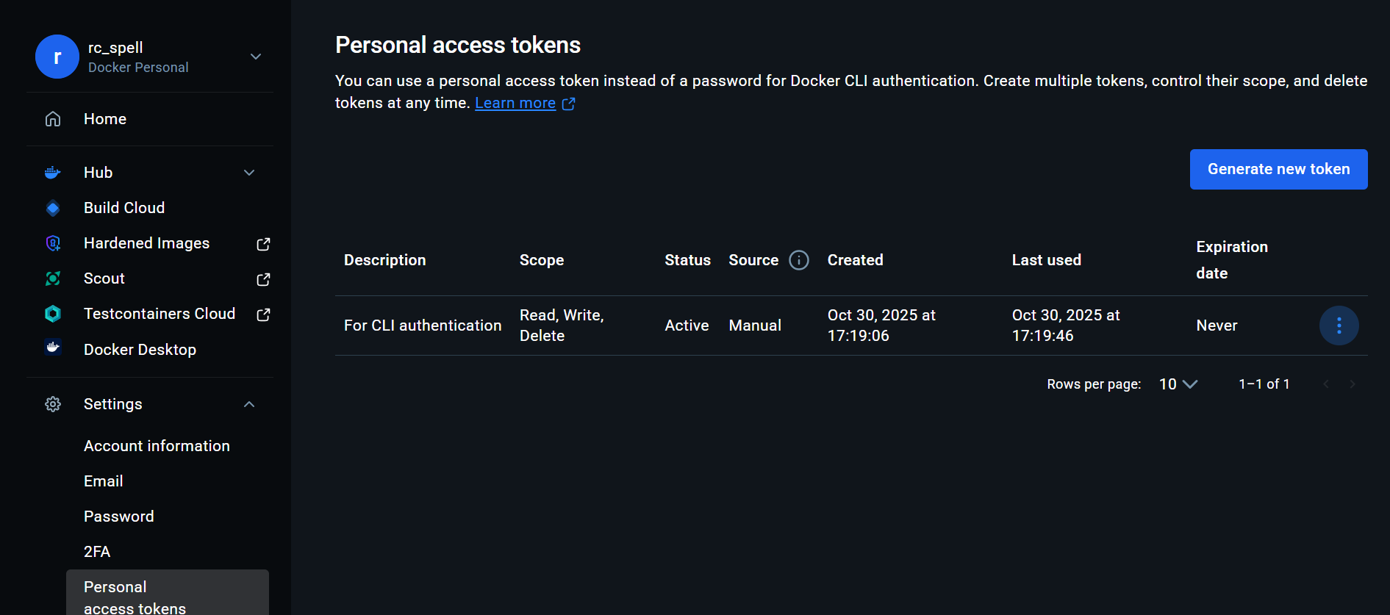

If you push it now it will work fine

You will notice the **tag** and **image id** for helloworld and rcspell/hello-world-java-bychhavi is same

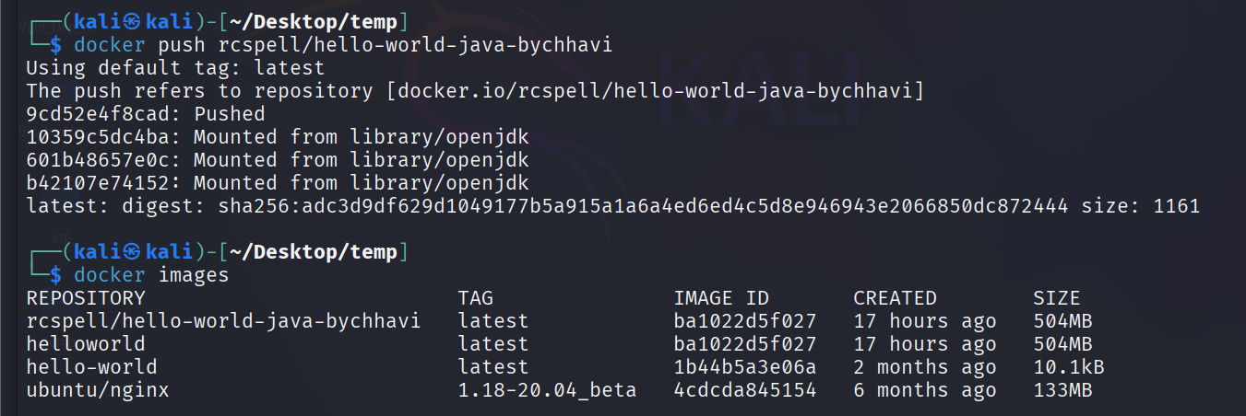

If you refresh on Docker hub you will find image has been added there.

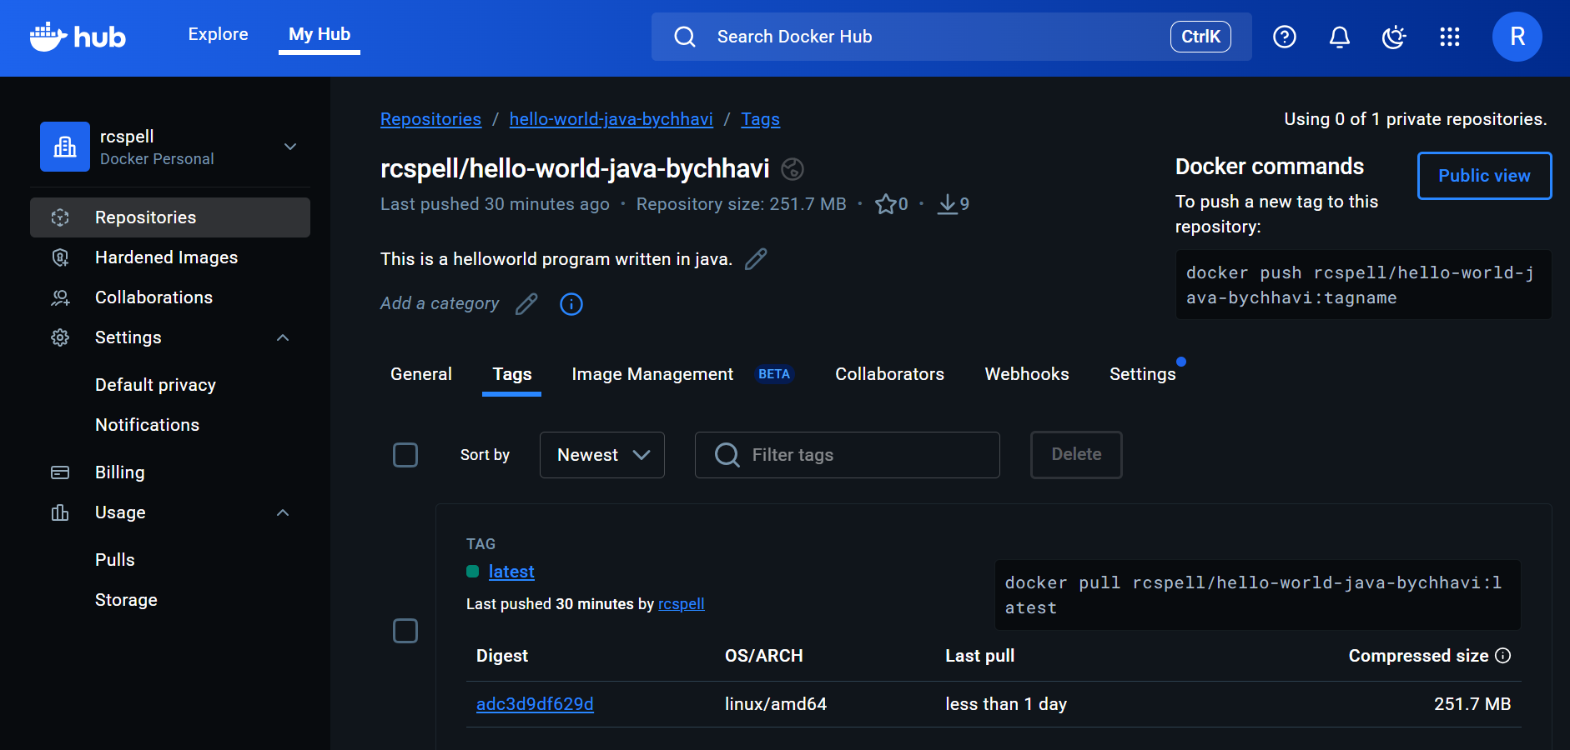

Now we will pull back this image to our system and run it to see if it’s working fine.

To avoid any confusion with previous “*helloworld*” or “*hello-world*” or “*rcspell/hello-world-java-bychhavi*” images we will be deleting them from the system then we will pull the “*hello-world-java-bychhavi*” image from Docker hub.

**To delete an image**

* docker rmi <image_id>

or

* docker rmi <name>

**NOTE:** You **cannot remove an image** if a container (even stopped) still exists that uses it. Therefore first remove the container using the following command

* docker rm <container_id>

and then remove the image else it will through error.

**TIP:** If you want to **delete all the images, container and build cache** from your system you can use

* docker system prune -a

After all deletion I am only left with one image that will cause no confusion to our work.

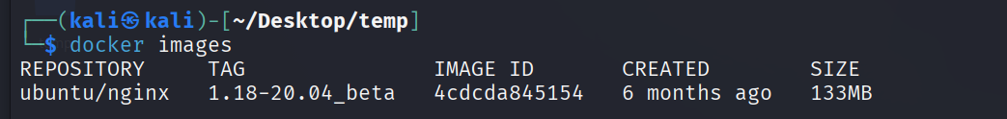

Let’s pull the image from Docker hub

* docker pull rcspell/hello-world-java-bychhavi

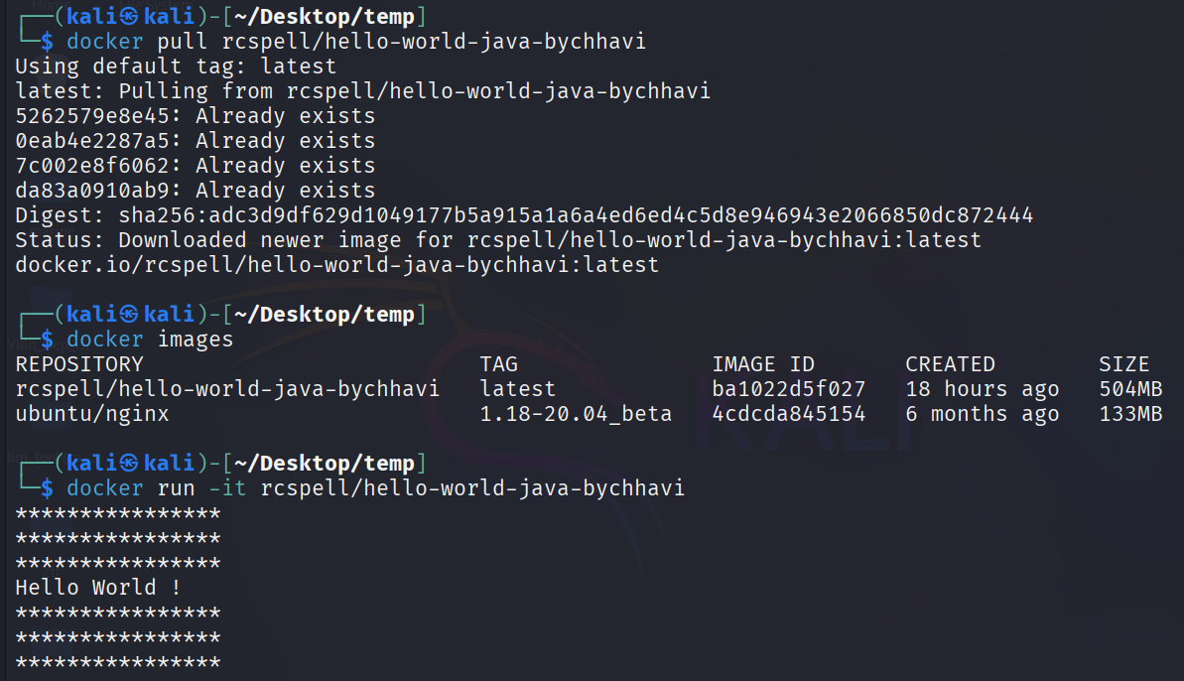

Yayy! We have successfully pulled our build image from Docker hub  
We can see we have now it as an image in our system.   
And it runs fine.

1. **Spring boot application with H2 Database**

Prerequisites to know and understand

**Spring boot:** Spring Boot is a java framework that simplifies the creation of standalone, production-grade Spring-based applications by providing default configurations and auto-configuration features, allowing developers to get started quickly without extensive setup.

**H2 database:** H2 is an open-source, lightweight, in-memory database written in Java that is fast**.** Spring boot intrinsically supports databases like H2, requiring no extra configuration for basic use. **Maven:** Maven is a project management and comprehension tool used primarily for Java projects, which manages dependencies, builds, and project structure through a Project Object Model (POM) file, enabling consistent builds across different environments.

* sudo apt-get update -y
* sudo apt install openjdk-11-jre-y
* sudo apt-get install maven-y

**Tomcat:** Tomcat is an open-source web server and servlet container developed by the Apache Software Foundation, which is used to serve Java-based web applications; Spring Boot includes an embedded Tomcat server by default, allowing applications to be run as standalone JAR files without needing a separate web server.

Here we are going to deploy a spring boot application to docker hub as image; that uses H2 database and we will build it using maven and it uses tomcat

You can use any application present online on GitHub. I preferably use the following

<https://github.com/danielpm1982/springboot2-meeting-mng/>

**Tip:** Make sure application allow running through docker

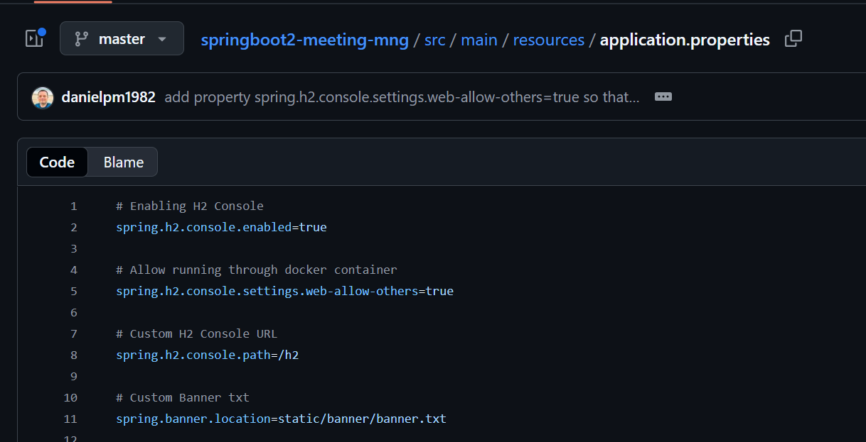

* git clone <https://github.com/danielpm1982/springboot2-meeting-mng.git>
* cd springboot2-meeting-mng
* mvn clean package
* cd target

new folder created with name target as a result of maven

copy to bring the compressed jar file to main folder

* cp springboot2-meetingmng-0.0.1-SNAPSHOT.jar /home/kali/Desktop/temp
* java -jar springboot2-meetingmng-0.0.1-SNAPSHOT.jar

check localhost:8080

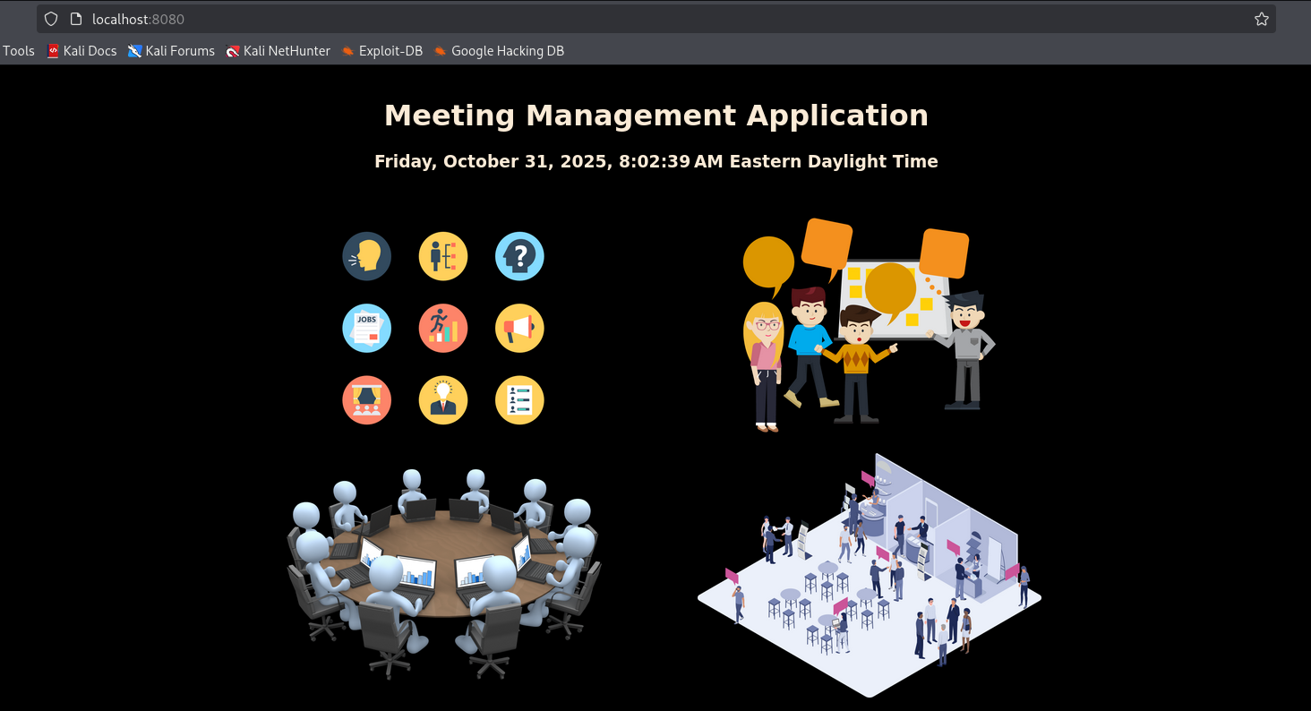

* nano Dockerfile

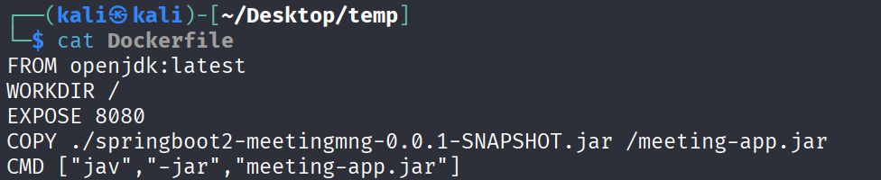

* docker build -t meeting-app .
* docker images

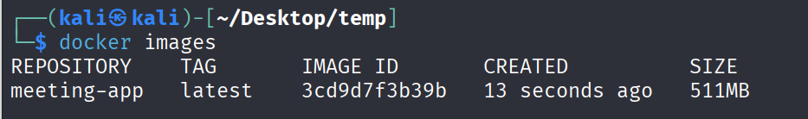

* docker run -it -p 8080:8080 meeting-app

Your application will run fine

To access the database   
localhost:8080/h2

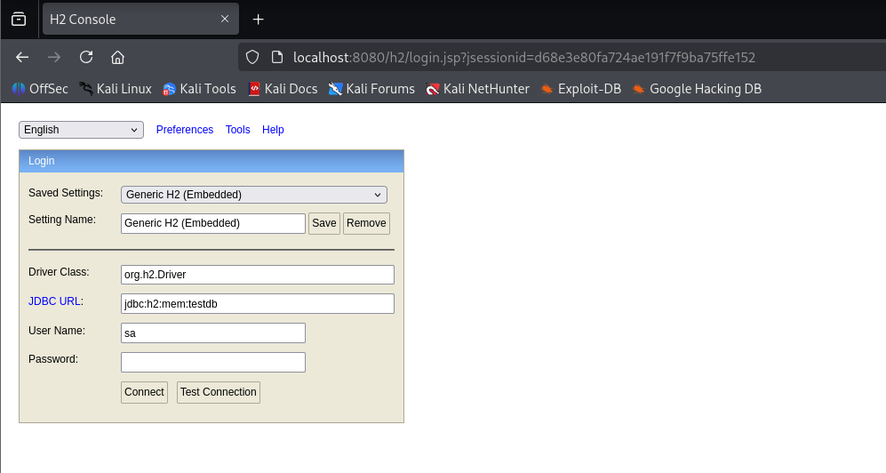





In the JDBC URL: add the instance from database  
and username as “SA”  
password is nil

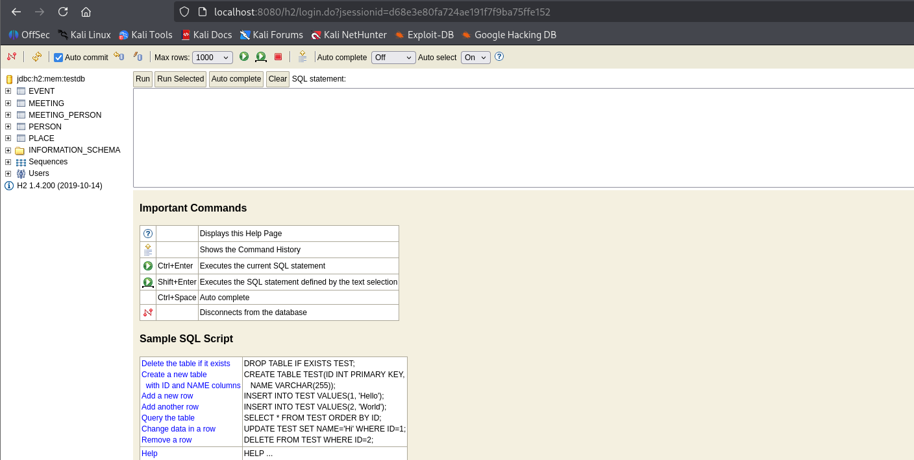

* create a repo on docker hub
* docker tag meeting-app rcspell/springboot-meeting-app
* docker push rcspell/springboot-meeting-app

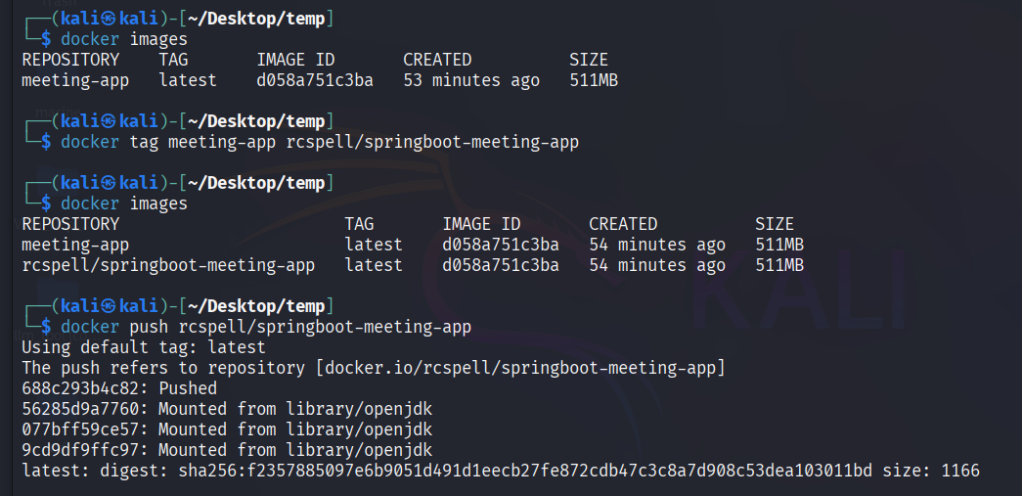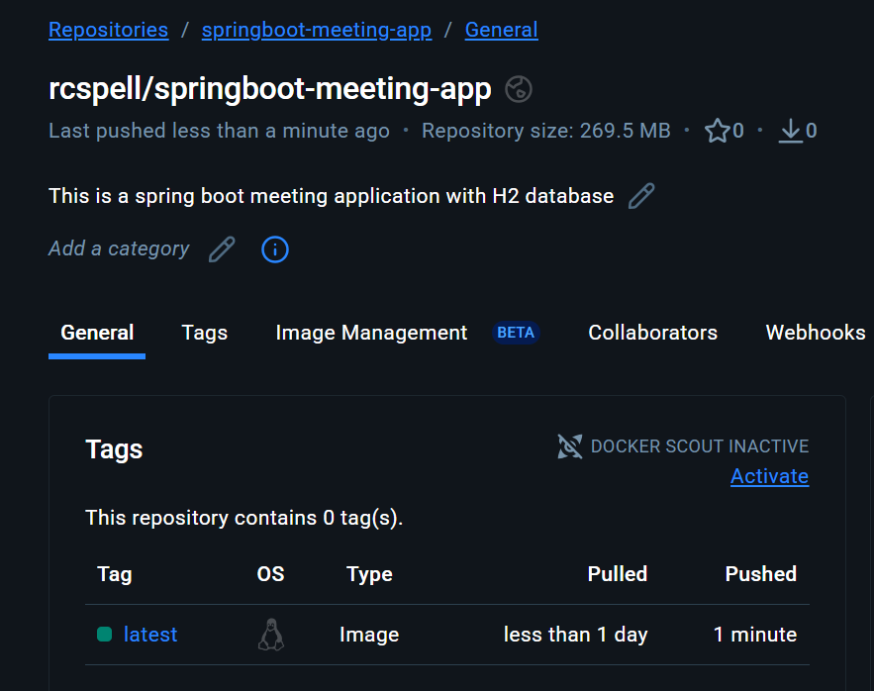

* docker system prune -a *(to delete all the images, container and build in cache)*
* docker pull rcspell/springboot-meeting-app:latest

to pull the image from docker hub; to validate

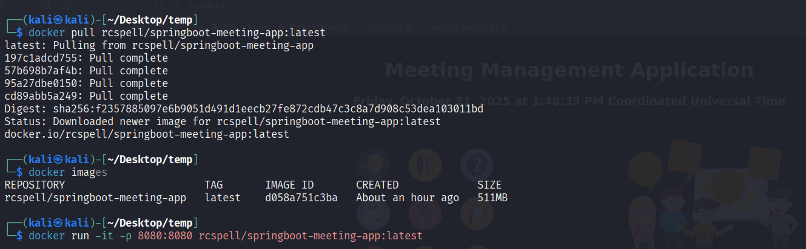

1. **Run MySQL inside container and link volume (storing location) to local system.**

**Mapping port of local system with port of container**

**Establishing a connection between the outside and internal environment of Docker. (Using MySQL Workbench to make changes to MySQL server inside container)**

**Volume:** There is a volume associated with each container means each container occupy space for storage and so do images and when these containers or images are deleted the data associated with them also vanishes.

**MySQL Workbench:** MySQL Workbench is a graphical user interface (GUI) tool designed for managing MySQL servers and databases.It serves as a client application that connects to a MySQL server to perform tasks such as creating databases, executing SQL queries, designing database schemas, and managing server configurations.

**MySQL server:** The MySQL server, on the other hand, is the core software responsible for storing, processing, and managing the actual data. A command-line interface (CLI) such as the mysql command-line client can be used to connect to and manage the server directly.

While MySQL Workbench can be used to design database models or write SQL scripts without an active connection, it cannot execute commands like CREATE DATABASE or INSERT data without a running MySQL server to process them. The server is essential because it manages the data files and handles all data storage, retrieval, and query processing. Without the server running, Workbench cannot establish a connection or perform any database operations.

**Create a folder for local volume to store sql data**

* mkdir sql-data

**We can directly pull docker image using run command without explicitly using “docker pull”**

* docker run --name mysql-sever-bychhavi -p 3306:3306 -p 33060:33060 -v /home/kali/Desktop/temp/sql-data:/var/lib/mysql -e MYSQL_ROOT_PASSWORD=root -d mysql:8

-p: port mapping (os:docker)

-v: volume (full_os_path: docker_location)

-e: environment variable -> “MYSQL ROOT PASSWORD” is “root”

-d: detached mode i.e in background

Mysql:8 means mysql image where tag/version is 8

* docker exec -it myql-sever-bychhavi bash

-it: i is iteratively and t is for current terminal

exec: execute command in docker container’s operating system i.e linux in this case

bash : the command that will get executive

After all these we will enter into mysql container and will call mysql server using mysql command line

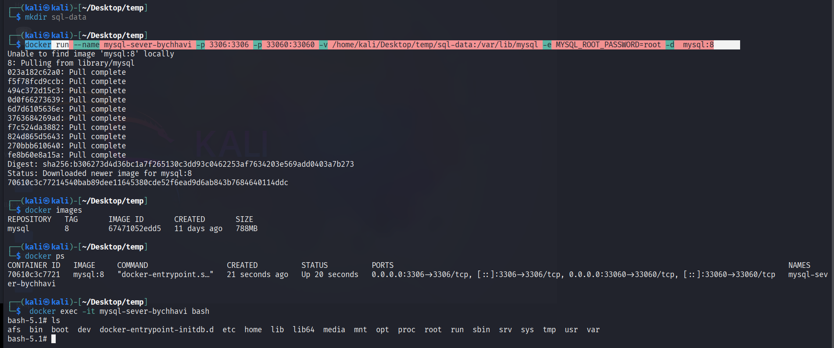

You will see few databases are already added to the sql-data



* mysql -u root -p

and the enter password

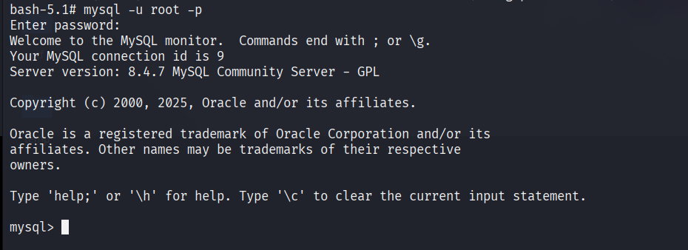

* show databases; *(To show databases)*
* use mysql; *(To use any database)*
* show tables; *(To show tables in database)*
* desc table_name; *(To see schema of any table)*
* create table client(client_id int not null, client_name varchar(20), primary key(client_id));
* 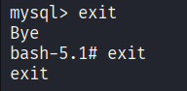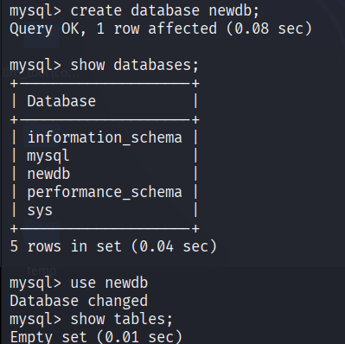insert into client values(1, "rachel");
* insert into client values(2, "monika");
* select * from client;

Now install mysql workbench and then

* mysql-workbench

It will work the same way as we worked with mysql cli

1. **Run Integrate Multiple Containers Using Links - Spring Boot and MySQL**

In this section we will be working with mysql image we downloaded in above section and link it with the spring boot meeting application (we have already worked with it as well though the branch used if different) means we will connect two containers together

* git clone -b mysql-db <https://github.com/danielpm1982/springboot2-meeting-mng.git>

b: branch = mysql-db

* cat src/main/resources/application.properties

here we can see this file is different

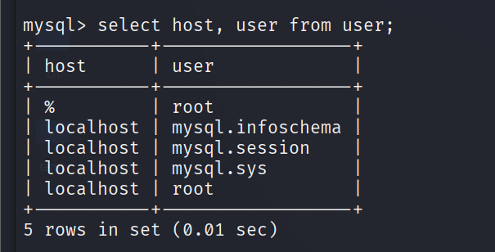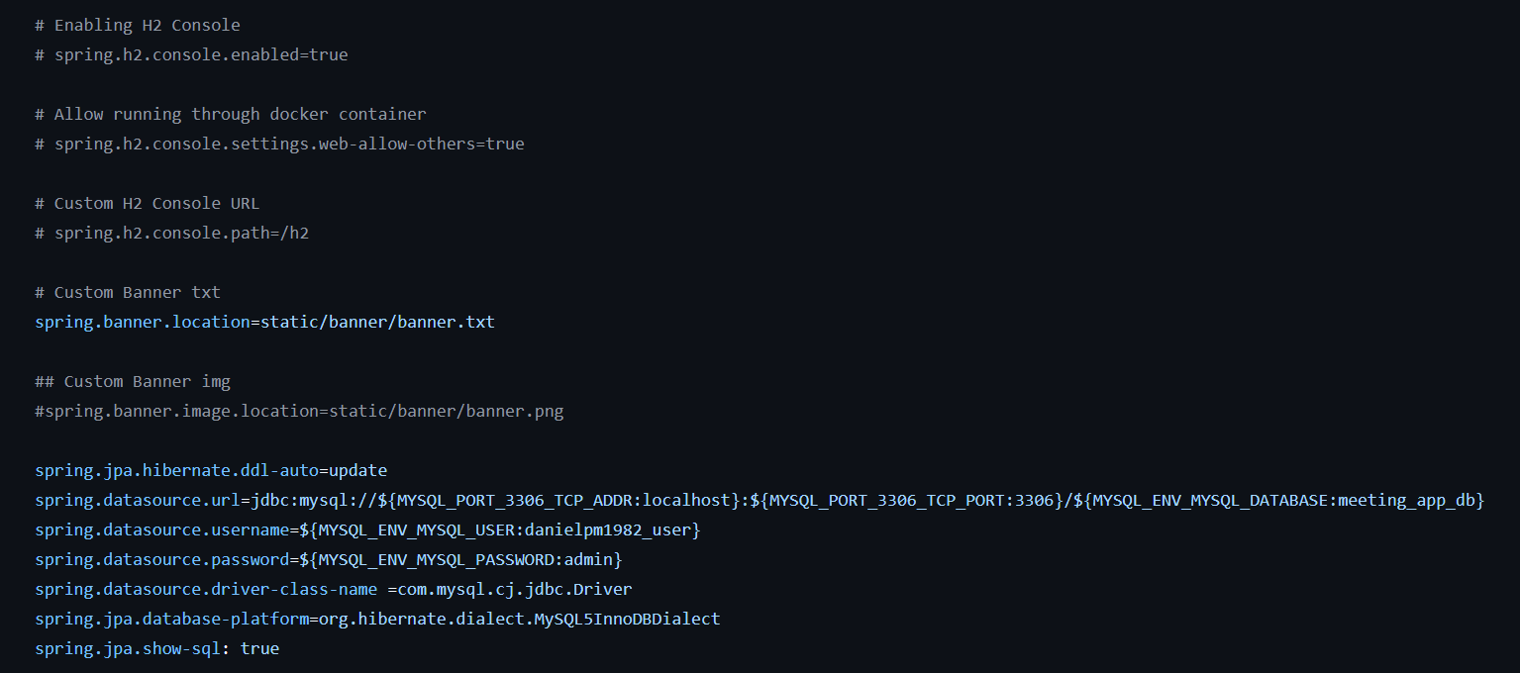

start the mysql container

login into mysql

* use mysql database
* when you describe user table
* you will see user and host entry
* select user and host from user table

In the screenshot you can see we have a user root which can be accessed from % (any character name) and localhost name host.

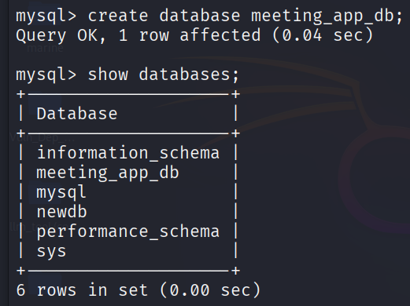It specifies possible host names that we can use username root to access the data

* Create a DB for springboot application meeting_app_db
* Create a user (check command based on mysql version)
* create user ‘rcspell’@’%’ identified by ‘admin’;

Username: rcspell

@ specify for user rcspell what are the possible hostname

Identified by password: admin



* grant all on meeting_app_db.* to ‘rcspell’@’%’ identified by ‘admin’;

all: all actions

database name.* means ‘*’ is all tables in meeting_app_db







You can revoke and provide specific rights as well for now we need full rights so use “grant all”

* login as newly created username

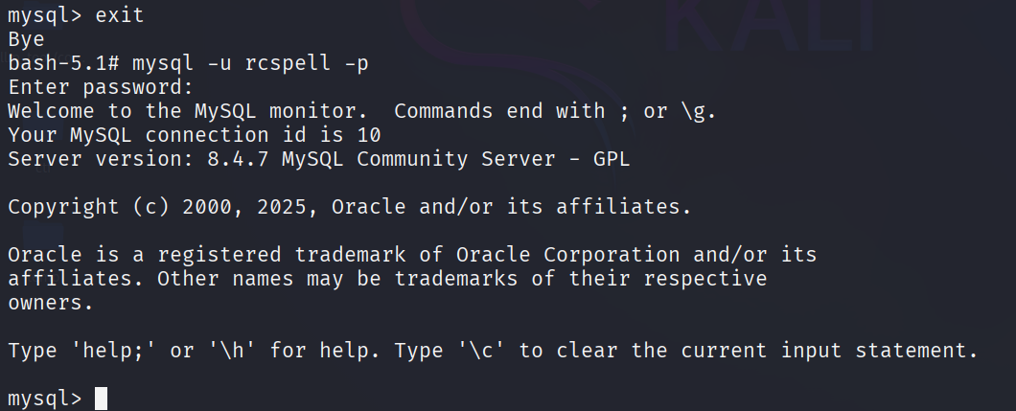

Now you can build the spring boot project using maven command **but make sure you change the username and password in application.properties file.**

Once the jar file is created

* java -jar springboot2-meetingmng-0.0.1-SNAPSHOT.jar

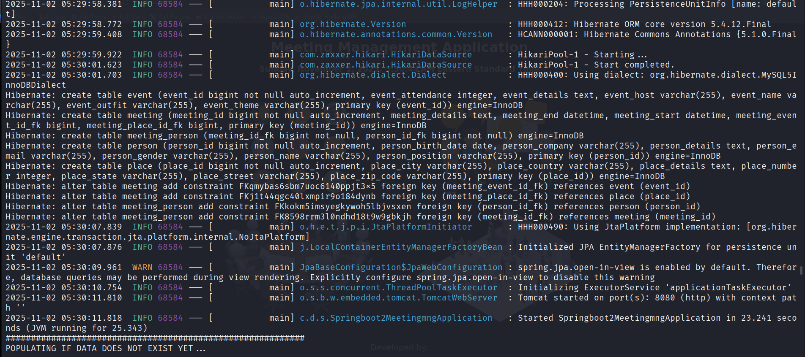

It will create the meeting and person if not exist (it is written in source code of our application)

And now we can only grant select, update, insert, delete rights (CRUD Operations)

In conclusion we will first set user privileges in mysql so that hibernate can create the schema and later we will restrict those privileges to only CRUD commands because hibernate won’t need to recreate the schema unless you delete the external folder where we saving all the database data here at the /temp

* now build an image with this spring boot application and then a container

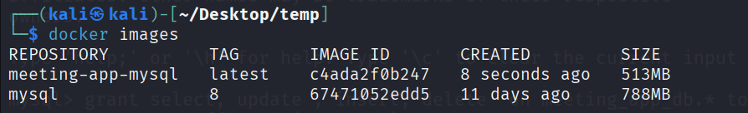

* docker run --name meeting-app-mysql-container --link mysql-sever-bychhavi:mysql -p 8080:8080 -e MYSQL_PORT_3306_TCP-ADDR:mysql-sever-bychhavi -d meeting-app-mysql

--name: name of the spring boot application container

--link: connect two containers here it connect mysql-server-container and the alias used for this link is mysql

-p: map os port to container port

-e: map env variable in the application.properties to mysql server

-d: detached mode in bg

lastly name of image we want to use to make a container (image:tag if any)

1. **Networking Theory**

Recommended: <https://docs.docker.com/engine/network/>

Container networking refers to the ability for containers to connect to and communicate with each other, and with non-Docker network services.

Containers have networking enabled by default, and they can make outgoing connections. A container has no information about what kind of network it's attached to, or whether its network peers are also Docker containers. A container only sees a network interface with an IP address, a gateway, a routing table, DNS services, and other networking details.

**Daemon:** In Linux, a daemon is a background process that runs continuously without direct user interaction, often managing system services or responding to requests.

**Docker Engine/ Docker Daemon:** The Docker Daemon, also known as dockerd, is a specific type of daemon that runs in the background on a host system and serves as the core management component of the Docker platform.

It is responsible for managing all Docker-related operations, including the lifecycle of containers (creation, starting, stopping, pausing, and removal), image handling, network configuration, and storage volume management.

**Types of Network Drivers in Docker**

* docker network ls

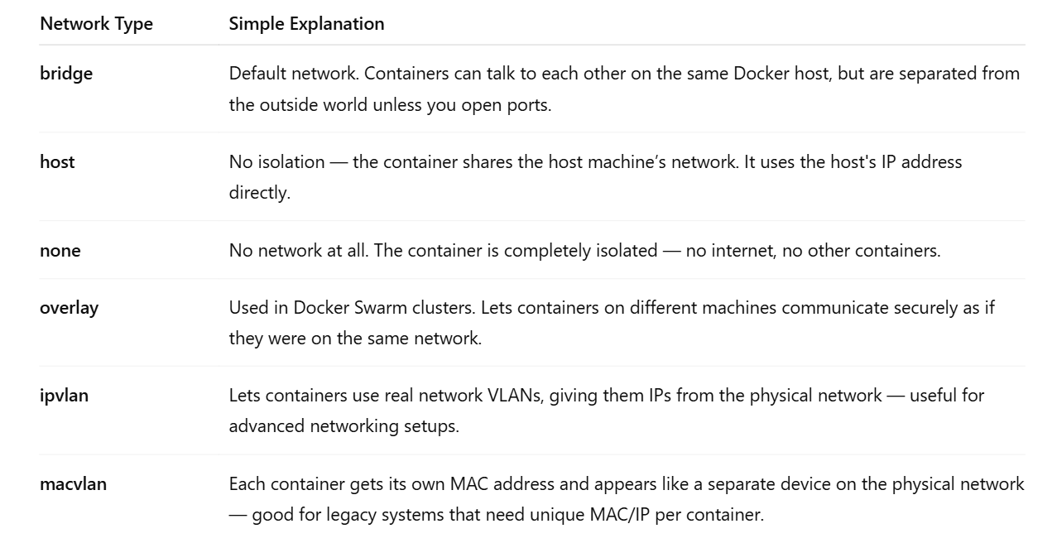

**Quick analogies** 🧠

**bridge** → Like devices connected to your home Wi-Fi network.

Containers on the default bridge network can communicate with the outside world (like the internet or other networks), not just with the host or other containers.

Think of the container like a laptop connected behind your home router:

Your laptop can browse the internet (like container can access outside network).

But strangers on the internet can't reach your laptop unless you open ports (same for containers).

* docker run –rm -it busybox:1 ping -c1 google.com

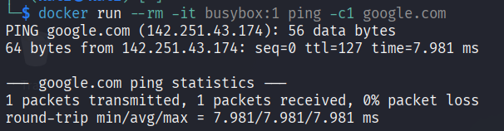

--rm: remove the container once it exits

-it: iterative mode in current terminal

-c1: number of ping request

Busybox: linux based container image

**host** → No router — the container plugs directly into your modem.

**none** → Airplane mode ✈️ — no network.

**overlay** → A private VPN connecting multiple servers together.

**ipvlan** → Containers join your office LAN using real IPs.

**macvlan** → Each container acts like a separate machine with its own network car.

**User-defined networks**

With the default configuration, containers attached to the default bridge network have unrestricted network access to each other using container IP addresses. They cannot refer to each other by name.

It can be useful to separate groups of containers that should have full access to each other, but restricted access to containers in other groups.

You can create custom, user-defined networks, and connect groups of containers to the same network. Once connected to a user-defined network, containers can communicate with each other using container IP addresses or container names.

**Differences between user-defined bridges and the default bridge**

**User-defined bridges provide automatic DNS resolution between containers.**

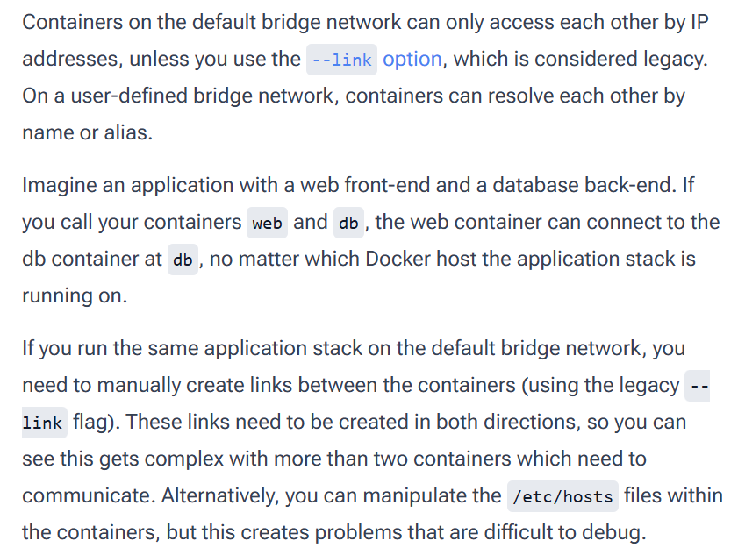

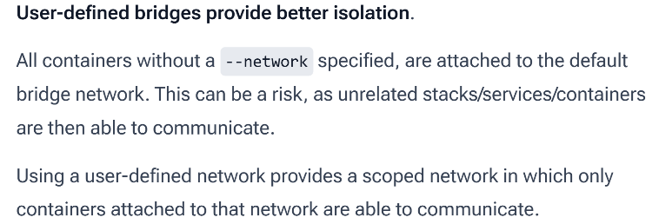 <https://docs.docker.com/engine/network/drivers/bridge/>

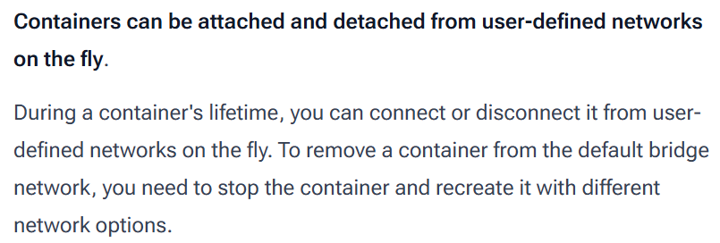



* above said is not true for newer version of docker we can disconnect network on fly

docker network disconnect network_name container_name

*docker --help or docker image --help or docker image ls --help*

* docker images *(is a shortcut but they don’t work with network)*
* docker image ls
* docker image ls -a *(list all image which are hidden by default)*
* docker volume ls
* docker network ls
* docker ps -a == docker container ls -a
* docker rm container_id == docker container rm container_id
* docker network --help
* docker network create -- driver or docker network create -d bridge
* docker network rm network_name

***-dit*** *: The -dit flag in Docker is a combination of three separate flags: -d, -i, and -t.*

*The -d flag runs the container in detached mode, meaning it runs in the background and allows the user to continue using the terminal.*

*The -i flag keeps the standard input (STDIN) open, even if the container is not attached to a terminal.*

*The -t flag allocates a pseudo-TTY (terminal) to the container, enabling interactive terminal sessions.*

*Together, these flags allow for the creation of a container that runs in the background but still supports interactive access, which is useful for managing long-running processes or services.*

[**https://docs.docker.com/engine/network/tutorials/standalone/#use-user-defined-bridge-networks**](https://docs.docker.com/engine/network/tutorials/standalone/#use-user-defined-bridge-networks)

* docker inspect container_name
* docker inspect network_driver (like bridge)

**To get inside container**

* docker exec -it alpine1 ash or
* docker attach alpine1

**To get out of container without stopping it**

* exit (but it will stop)
* Ctrl P + Ctrl Q

**To remove a network**

* docker network disconnect bridge alpine4
* docker network disconnect network_name container_name

**To add a network**

* docker network connect network_name container_name

No DNS resolution with default bridge network

**Now Practical**

The default bridge network demonstrates how to use the default bridge network that Docker sets up for you automatically. This network is not the best choice for production systems.

User-defined bridge networks shows how to create and use your own custom bridge networks, to connect containers running on the same Docker host. This is recommended for standalone containers running in production. (It creates group of the network on default bridge so that they can talk using DNS resolution i.e using name whereas for default bridge containers can only communicate using IP address)

* By default, we have bridge, host and null network driver
* We will create a user-defined bridge network with name alpine-net-userdefined-bridge
* docker network create --driver bridge alpine-net-userdefined-bridge

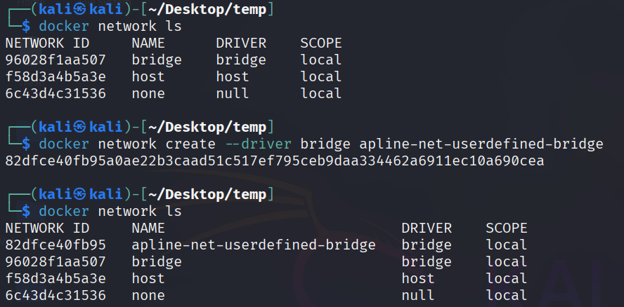

**Default bridge (we will use alpine image)**

* create two default bridge networks (ash is the bash command in alpine)

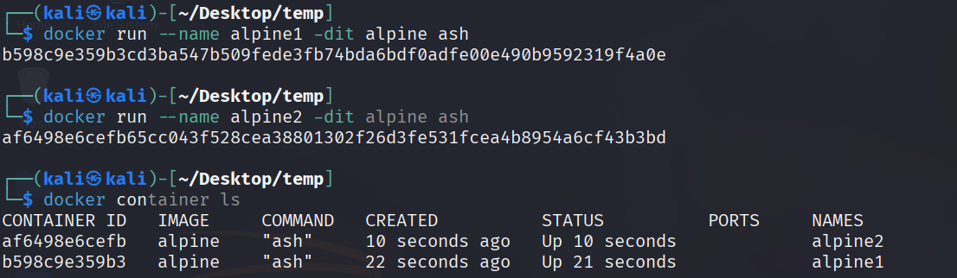

* docker inspect bridge

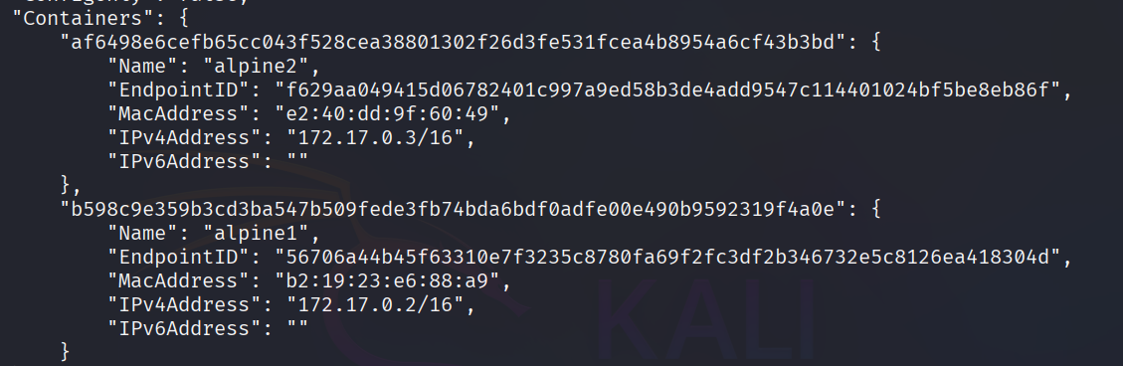

Here we have two containers connect on default bridge network and the IPs is also present

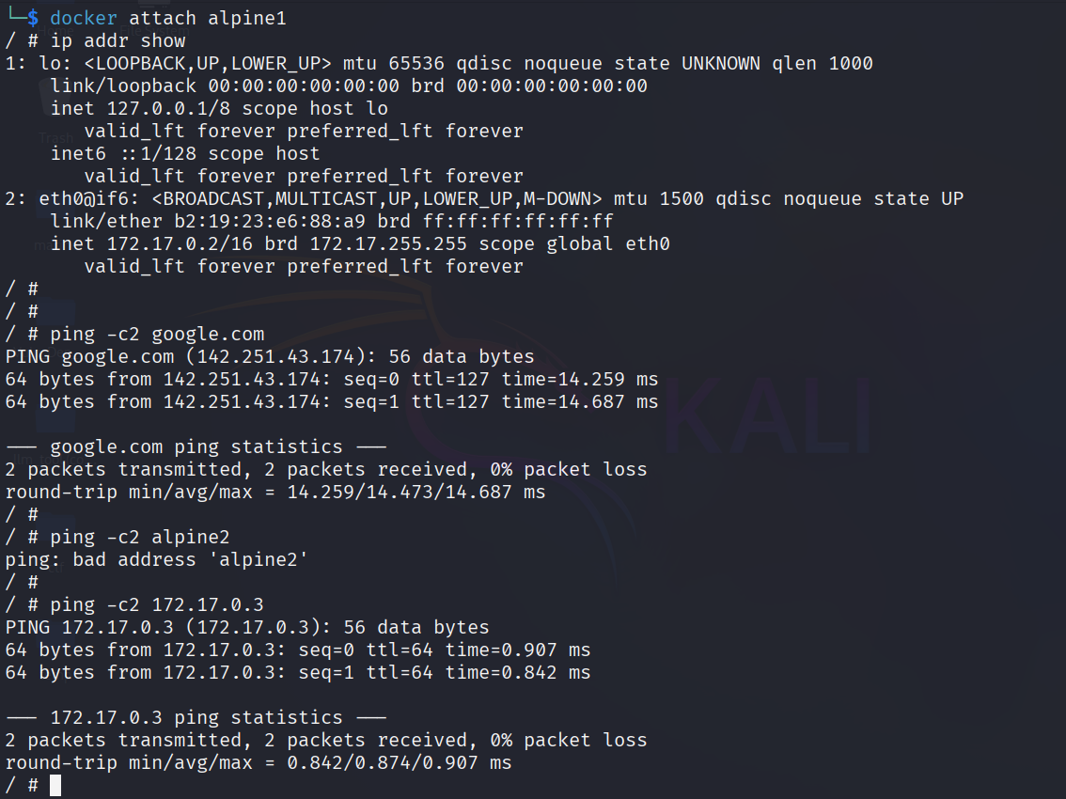



* Attach to apine1 and verify the IP with bridge inspect
* Try checking network connectivity using google ping
* Use the name of another bridge network alpine2 and ping you will see it says bad address because there is no DNS resolution with default bridge network
* Ping using IP address of alpine2 and it will work

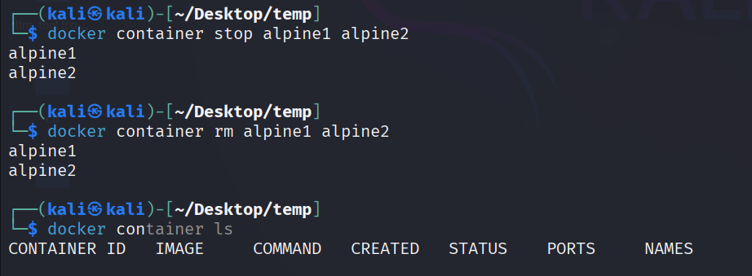

* Remove the containers after this practice

**User defined bridge**

* docker inspect apline-net-userdefined-bridge

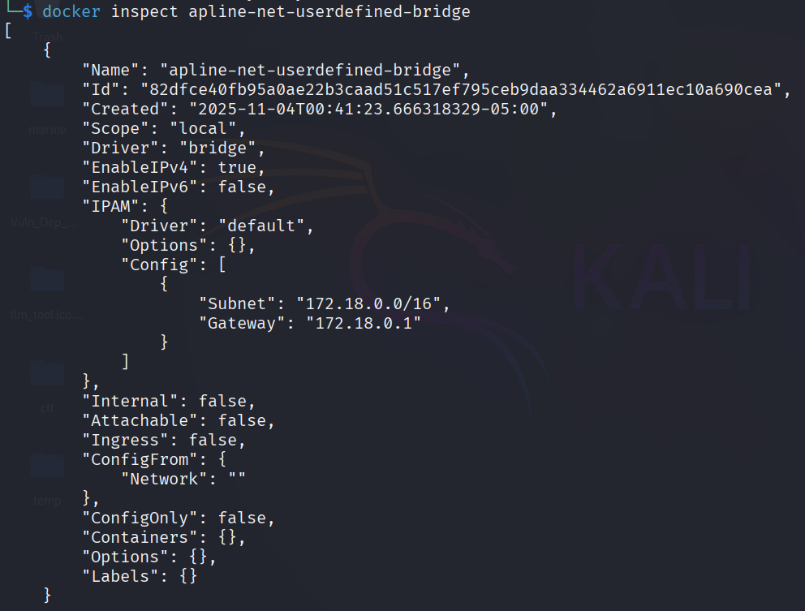

Here you can there are no container using this network

* create *two* containers on apline-net-*userdefined-bridge* say *alpine1* and *alpine2*
* create *one* network on *default bridge* say *alpine3*
* create *one* network on *both* apline-net-userdefined-bridge and default bridge say *alpine4*

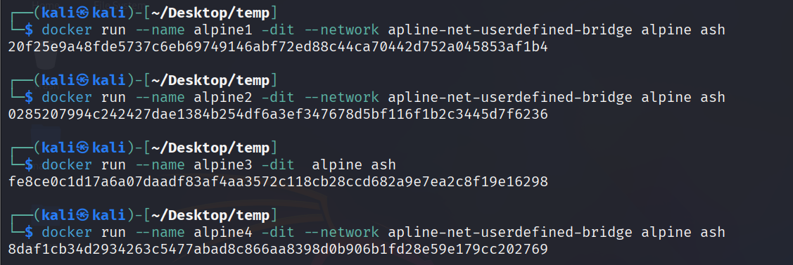

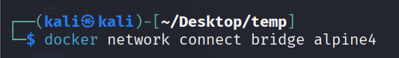

You can only connect to one network during the *docker run* command, so you need to use *docker network connect* afterward to connect *alpine4* to the *bridge* network as well.

Verify that all containers are running:

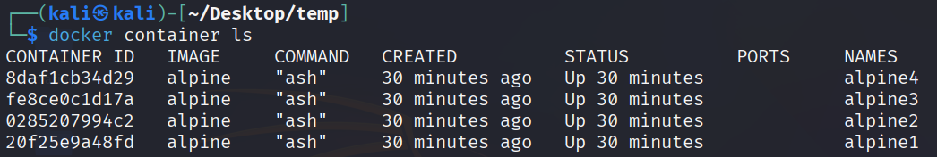

* inspect *bridge* and *apline-net-userdefined-bridge* again

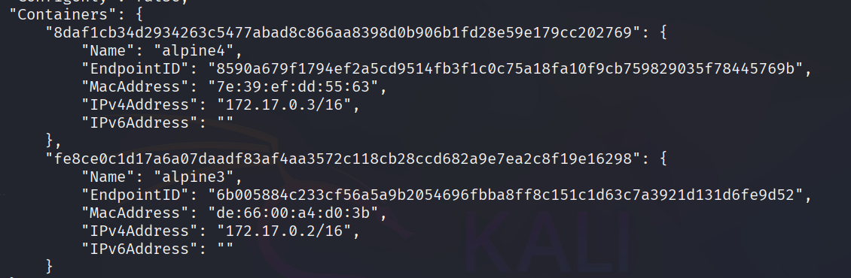

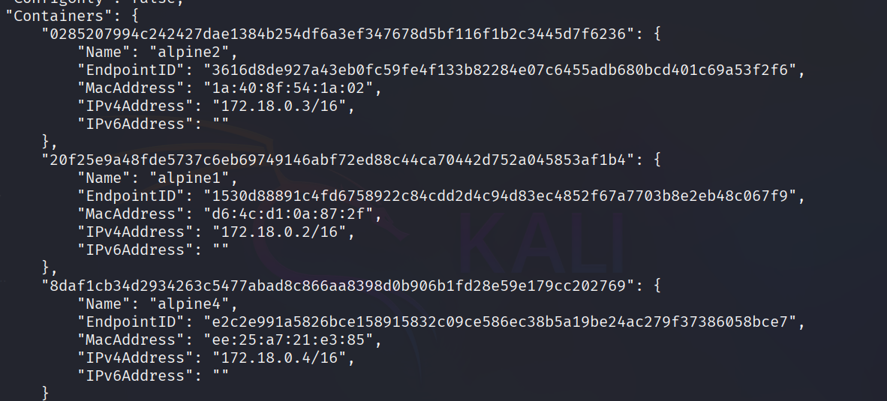

Now we have two containers in bridge – alpine4 and alpine3

And three in apline-net-userdefined-bridge – alpine2, alpine1 and alpine4

* Attach to apline1 and send ping request to other 3 networks
* From alpine1, you should not be able to connect to alpine3 at all, since it is not on the apline-net-userdefined-bridge network. Not only that, but you can't connect to alpine3 from alpine1 by its IP address either.

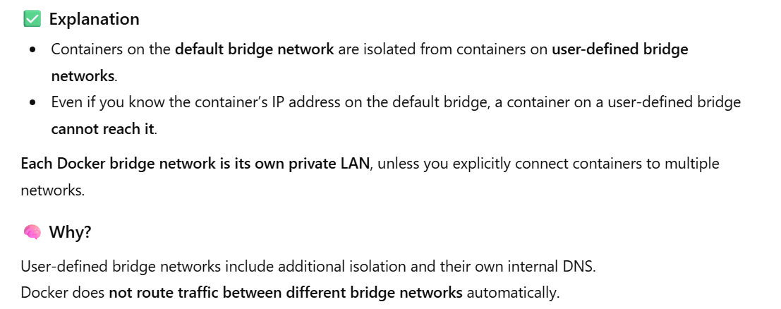

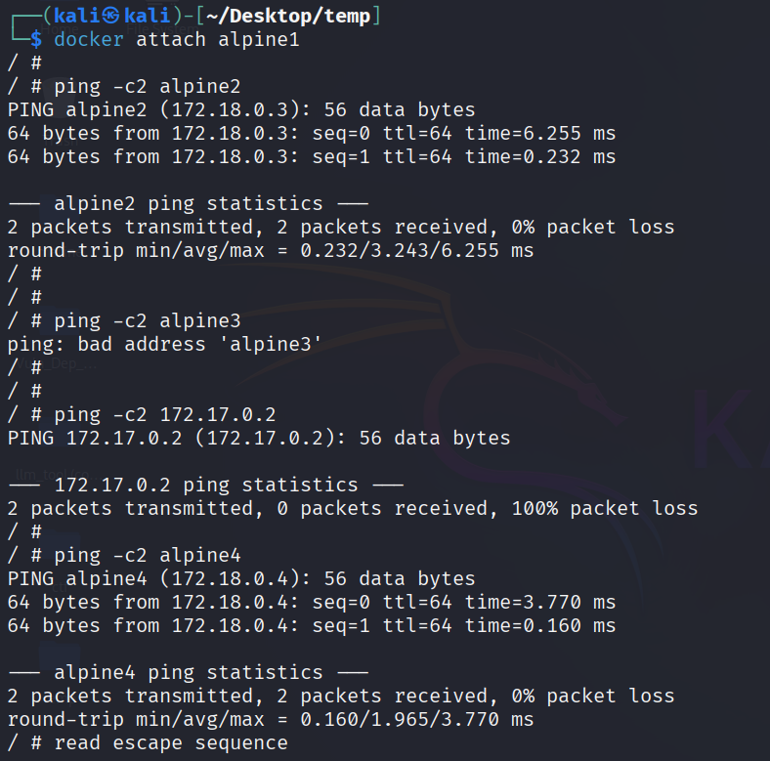

* Now attach to alpine4 since it is connected to both network it would be able to reach out to each

one of them

* But remember it can ping alpine3 using IP only since they are a part of default bridge. (No DNS)

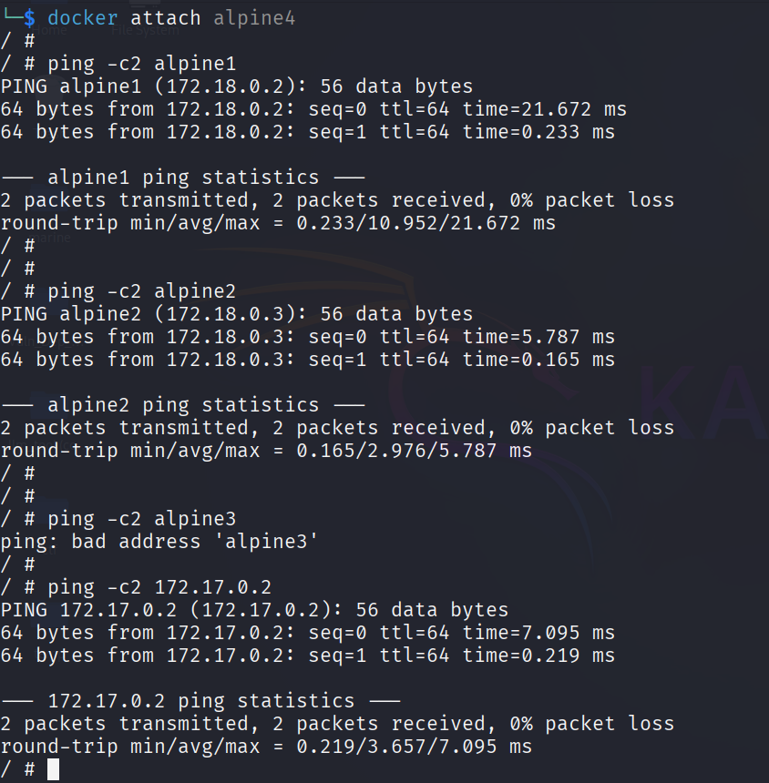

**To clean everything**

* docker container stop alpine1 alpine2 alpine3 alpine4
* docker container rm alpine1 alpine2 alpine3 alpine4
* docker network rm apline-net-userdefined-bridge

1. **Links and Environment variable**

[**https://docs.docker.com/engine/network/links/**](https://docs.docker.com/engine/network/links/)

--link <name or id>: alias

For port -p or -P

docker port container_name

1. **Docker compose**

<https://docs.docker.com/compose/>

https://docs.docker.com/compose/gettingstarted/

<https://yaml.org/>

Docker Compose is a tool for defining and **running multi-container applications**. It is the key to unlocking a streamlined and efficient development and deployment experience.

User defined bridge network

docker-compose.yml

* docker compose up
* docker compose down